

**[Getting Personal]**

**[PPC Landing Pages]**

**TEST PLAN**

**BACKGROUND**

|  |
| --- |
| **EVIDENCE:**  Of the top conversion paths PPC accounts for 60% of all conversions  Over the last 3 months, PPC conversion generated over 200K and is one of the highest converting channels  Ensuring relevant and consistent ad copy through to landing page improves quality score and conversion rates. |

|  |
| --- |
| **PAGE(s):**  **Top level/Traffic Category Pages from PPC.** |

|  |  |  |  |
| --- | --- | --- | --- |
| **MUV:**  60,000 |  | **TEST TYPE:**  A/B |  |

_______________________________________

**OBJECTIVE**

|  |
| --- |
| **HYPHOTHESIS:**  Ensuring landing page content is relevant to the advert copy and simplified to take users to where they need to go will increase search relevance and therefore conversion. |

|  |
| --- |
| **TEST GOAL:**  Increase conversion rate and revenue from PPC traffic |

|  |
| --- |
| **KSM(s):**   * Conversions * Revenue |

_______________________________________

**VARIANTS**

|  |
| --- |
| **INFORMATION:**  Default   1. Simplified PPC Landing Page |

**TARGETING**

|  |
| --- |
| **DOMAINS:**   * [Www.gettingpersonal.co.uk](http://Www.gettingpersonal.co.uk) |

Clear bindings (error: cannot apply bindings multiple times to the same element)

ko.cleanNode(document.getElementById('elt1'));

|  |
| --- |
| **URL(s):**  <https://www.gettingpersonal.co.uk/cards> => loop over it  <https://www.gettingpersonal.co.uk/birthday-presents/birthday-gifts.htm> => loop over it  <https://www.gettingpersonal.co.uk/anniversary-presents/anniversary-gifts.htm> => working good ok scroll/links  <https://www.gettingpersonal.co.uk/gifts-for-him/personalised-gifts-for-him.htm> => working good ok scroll/links  <https://www.gettingpersonal.co.uk/gifts-for-her/personalised-gifts-for-her.htm> => hero no-show  <https://www.gettingpersonal.co.uk/personalised-presents/personalised-gifts.htmm> => hero no-show |

|  |  |
| --- | --- |
| **DEVICES:**   * Desktop | **BROWSERS:**   * Chrome 45+ * Firefox 45+ * IE9+ |

|  |
| --- |
| **OTHER:**  URL must contain gclid parameter |

_______________________________________

**METRICS**

|  |  |  |
| --- | --- | --- |
| NAME | TYPE | DESCRIPTION |
| 1.       Sales Confirmation | Primary | Confirmation page |
| 2.       Revenue | Revenue | Total Revenue |
| 3.       Burger menu interaction (Mobile) | Click | Users interacting with the burger menu |
| 7.       Login Icon | Clicks | Icon within header |
| 8.       Login Page | Page Views | https://www.gettingpersonal.co.uk/accounts/login |
| 9.       Existing Customer login – Successful |  | Users successfully logging in |
| 10.    New Customer Login – Create account | Page Views | https://www.gettingpersonal.co.uk/accounts/create-account |
| 11.    Mini-Basket (Bag) | Clicks | Mini bag clicks – Navigation Menu |
| 12.    Funnel Step 1 Basket | Page Views | https://www.gettingpersonal.co.uk/basket.htm |
| 13.    Funnel Step 2 Checkout | Page Views | https://www.gettingpersonal.co.uk/checkout.htm |
| Variation Goals |  |  |
| 14. Hero Banner CTA Clicks | Click | CTA banner hero clicks |
| Control Only Goals |  |  |
| 15. Navigation link clicks | Click | Users using the navigation |
| 16. Side Filter/Navigation Interaction | Click | Users using the side filter/navigation |

**ATTRIBUTES**

|  |  |  |
| --- | --- | --- |
| **SEGMENT** | **DESCRIPTION** | **STATUS** |
| Device: Desktop | - |  |
| Device: Table | - |  |
| Device: Mobile | - |  |
| PPC Traffic | Source from PPC Traffic |  |

* Attributes are utilised to segment results’ data

_______________________________________

**INTEGRATIONS**

|  |  |
| --- | --- |
| **TOOL** | **SLOT / TAG INFORMATION** |
| GA Universal | Slot 4 |
| HotJar | - |
| **NOTES:** | |

**DEFAULT**

|  |
| --- |
| **DESKTOP:** |

**DESIGN CHANGES**

n/a

**CONSIDERATIONS**

n/a

**VARIATION #1**

|  |
| --- |
| **DESKTOP:** |

**DESIGN CHANGES**

Removed all content on page included the following

* Navigation links
* Side menu/navigation
* Content Blocks

**CONSIDERATIONS**

**Hero CTA to link to following pages**

<https://www.gettingpersonal.co.uk/birthday-presents/birthday-gifts.htm>

Link to <https://www.gettingpersonal.co.uk/birthday-presents/all-birthday-gifts.htm>

• <https://www.gettingpersonal.co.uk/cards>

Link to <https://www.gettingpersonal.co.uk/cards/all-personalised-cards.htm>

Hero Image Copy –

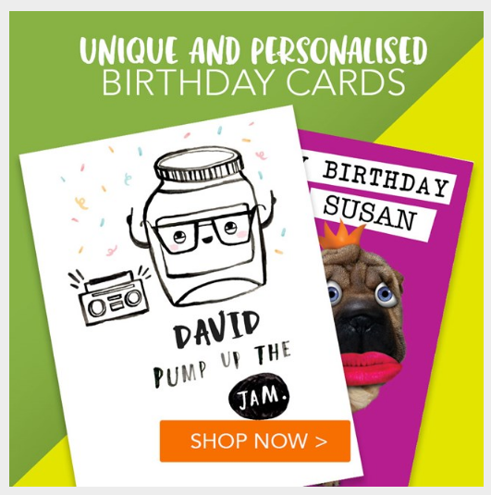

Images - 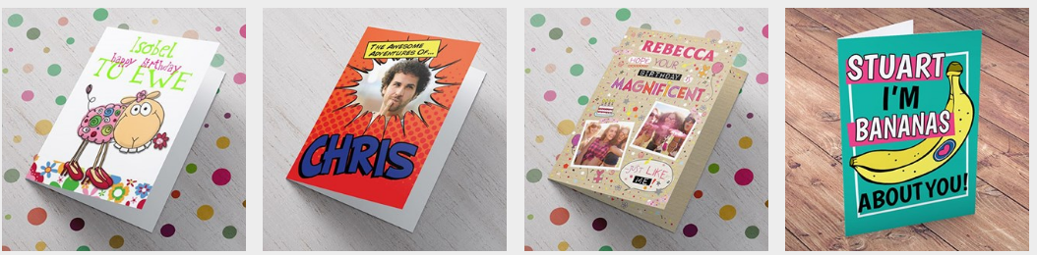

• https://www.gettingpersonal.co.uk/anniversary-presents/anniversary-gifts.htm

Link to <https://www.gettingpersonal.co.uk/anniversary-presents/anniversary-gifts-all.htm>



Images

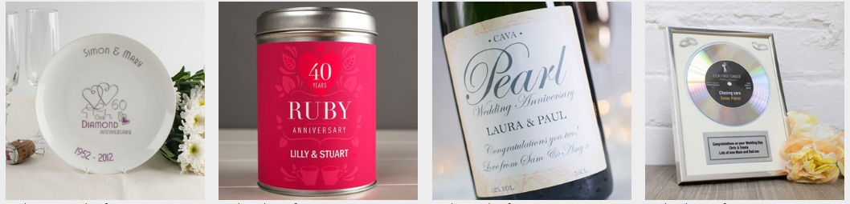

• <https://www.gettingpersonal.co.uk/gifts-for-him/personalised-gifts-for-him.htm>

Link to <https://www.gettingpersonal.co.uk/gifts-for-him/all-gifts-for-him.htm>

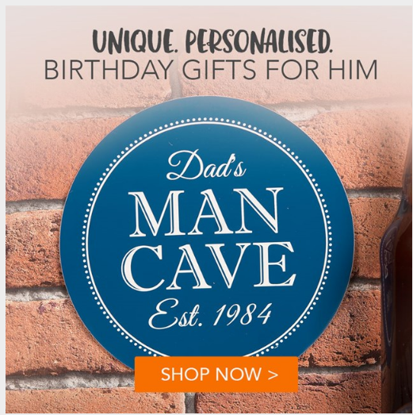

Images

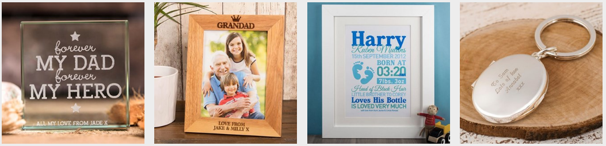

• <https://www.gettingpersonal.co.uk/gifts-for-her/personalised-gifts-for-her.htm>

Link to <https://www.gettingpersonal.co.uk/gifts-for-her/view-all-gifts-for-her.htm>



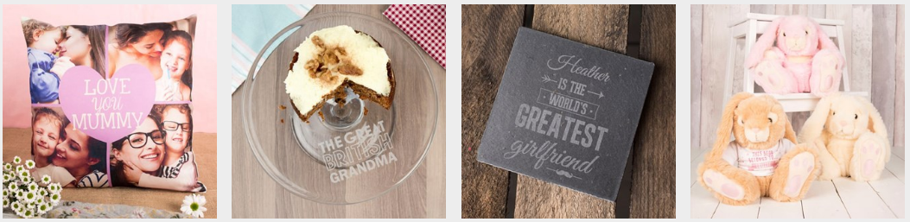

* <https://www.gettingpersonal.co.uk/personalised-presents/personalised-gifts.htm>

Link to <https://www.gettingpersonal.co.uk/personalised-gifts/all-personalised-gifts.htm>

Hero Copy

**Personalised Gifts & Present Ideas**

Explore our range of personalised gifts & find the perfect present for him, for her or for the kids

Images

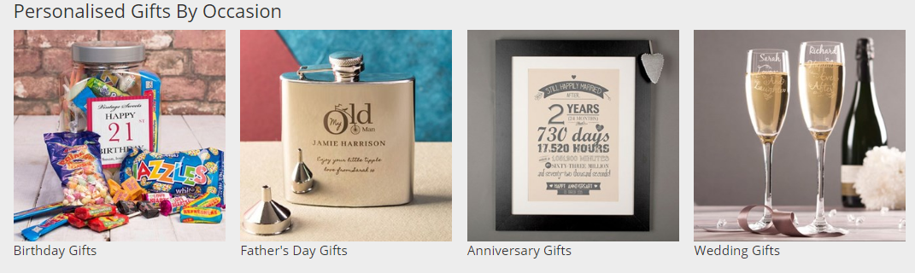

**QA: VARIATION 1**

**USER STORY:**

n/a

**QA SCRIPT**

|  |  |  |  |  |  |  |  |  |  |  |  |
| --- | --- | --- | --- | --- | --- | --- | --- | --- | --- | --- | --- |
|  | **DESKTOP** | | | | | | | **TABLET** | | **MOBILE** | |
| **INTERACTION** | **IE9** | **IE10** | **IE11** | **EDGE** | **CHM** | **SF** | **FF** | **iPad** | **Other** | **iPhone** | **Other** |
| [WWW.URL.COM](http://WWW.URL.COM) | | | | | | | | | | | |
| Element name |  |  |  |  |  |  |  |  |  |  |  |
| Element name |  |  |  |  |  |  |  |  |  |  |  |
| Element name |  |  |  |  |  |  |  |  |  |  |  |
| Element name |  |  |  |  |  |  |  |  |  |  |  |
| [WWW.URL.COM](http://WWW.URL.COM) | | | | | | | | | | | |
| Element name |  |  |  |  |  |  |  |  |  |  |  |

_______________________________________

**QA: VARIATION 2**

**USER STORY:**

n/a

**QA SCRIPT**

|  |  |  |  |  |  |  |  |  |  |  |  |
| --- | --- | --- | --- | --- | --- | --- | --- | --- | --- | --- | --- |
|  | **DESKTOP** | | | | | | | **TABLET** | | **MOBILE** | |
| **INTERACTION** | **IE9** | **IE10** | **IE11** | **EDGE** | **CHM** | **SF** | **FF** | **iPad** | **Other** | **iPhone** | **Other** |
| [WWW.URL.COM](http://WWW.URL.COM) | | | | | | | | | | | |
| Element name |  |  |  |  |  |  |  |  |  |  |  |
| Element name |  |  |  |  |  |  |  |  |  |  |  |
| Element name |  |  |  |  |  |  |  |  |  |  |  |
| Element name |  |  |  |  |  |  |  |  |  |  |  |
| [WWW.URL.COM](http://WWW.URL.COM) | | | | | | | | | | | |
| Element name |  |  |  |  |  |  |  |  |  |  |  |

**SOW**

|  |  |  |  |
| --- | --- | --- | --- |
| **DESIGN:** |  | **ESTIMATED HOURS:** |  |
| **TEST PLAN:** |  | **ESTIMATED HOURS:** |  |
| **DEVELOPMENT:** |  | **ESTIMATED HOURS:** |  |
| **QA:** |  | **ESTIMATED HOURS:** |  |
| **ANALYSIS:** |  | **ESTIMATED HOURS:** |  |
| **DEBRIEF:** |  | **ESTIMATED HOURS:** |  |
|  | | **TOTAL:** |  |

_______________________________________

**DELIVERABLES**

|  |  |  |  |
| --- | --- | --- | --- |
| **DELIVERABLE** | **SCHEDULLED** | **DELIVERED** | **LINK / NOTES** |
| Designs |  |  |  |
| Test Plan |  |  |  |
| Preview links |  |  |  |
| Data extract (Overall) |  |  |  |
| Data extract (Mobile) |  |  |  |
| Insights report (Overall) |  |  |  |
| Insights report (mobile) |  |  |  |
| Debrief Call |  |  |  |

**NOTES:**

Preview link: ?optimizely_xExperimentID=variationNumber

QA Videos: www.url.com

Results link: www.url.com



**RedEye Milton Keynes**

38 Shenley Pavilions,

Chalkdell Drive, Milton Keynes, Bucks, MK5 6LB

Tel: +44 (0) 1908 340 990

**RedEye Crewe**

Oak House, Crewe Hall Farm,  
Crewe, Cheshire, CW1 5UE

Tel: +44 (0) 1270 848 490

**RedEye London**35-38 New Bridge,  
London, EC4V 6BW

Tel: +44 (0) 207 730 9958

**Thank You**

For further information or to ask any questions, please contact:

Phone: 01270 242 658

www.redeye.com